Installing Python on Mac
Most Macs already come with Python 2 installed. To install Python 3.4 on a Mac visit https://www.python.org/downloads/release/python-344/ and scroll down to bottom under Files heading select the installer corresponding to your version of Mac OS.
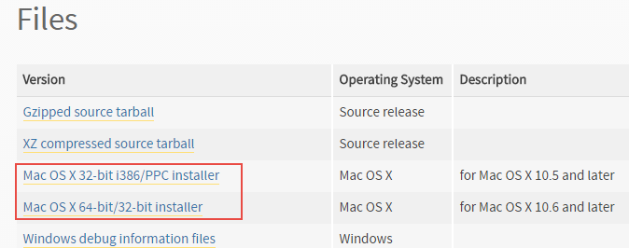
If you are using Mac OS X 32-bit system download Mac OS X 32-bit i386/PPC installer and if you are using Mac OS X 64-bit download Mac OS X 64-bit/32-bit installer. On a 64-bit system, both installers will work.
Double-click the downloaded file to start the installation process and accept all the defaults. Unlike Windows, Python installer for Macs automatically adds python to the PATH environment variable, so you don't need to do anything. To verify the installation execute the following command.
1  2  3 | Qs-Mac:~ q$ python3 --version  Python 3.4.4  Qs-Mac:~ q$

